CLOUD TRAIL&CLOUD WATCH
1.Enable CloudTrail monitoring and store the events in S3 and CloudWatch log events
I have created a new bucket
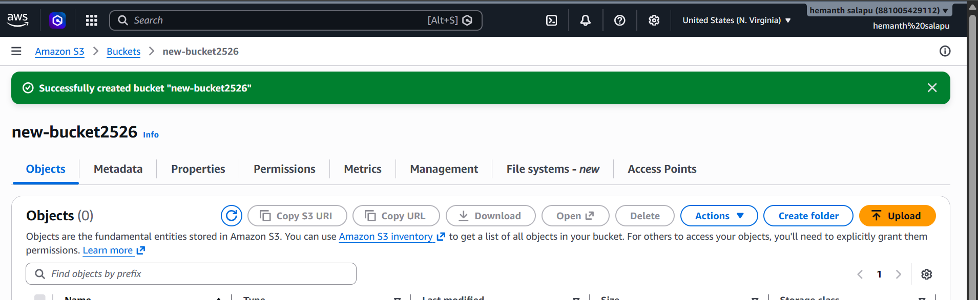
Created a trail
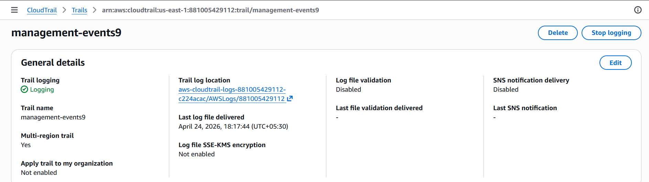
Created a log group
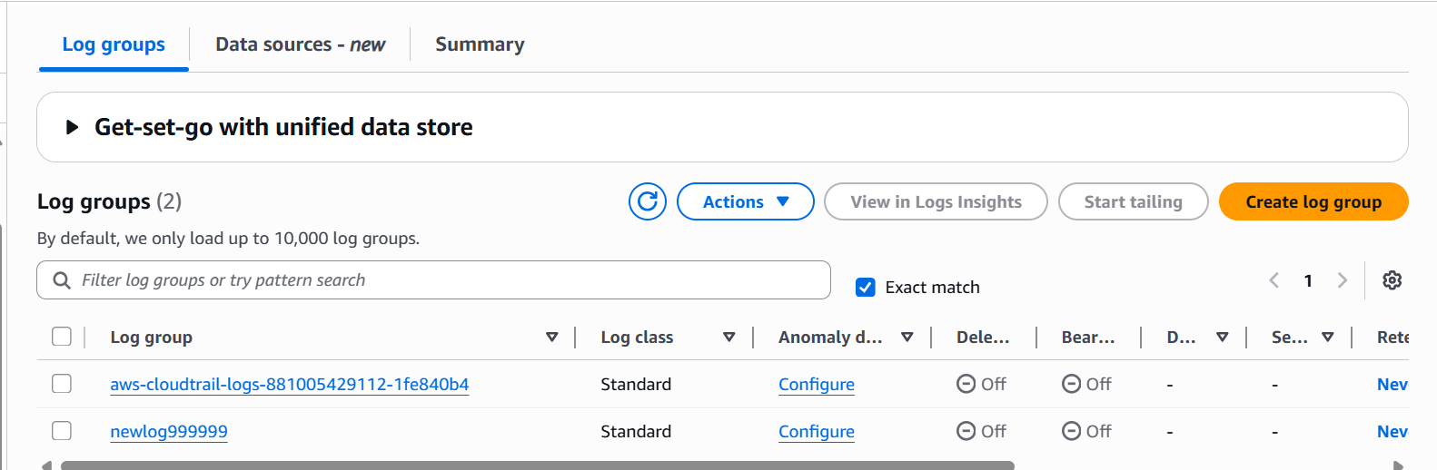
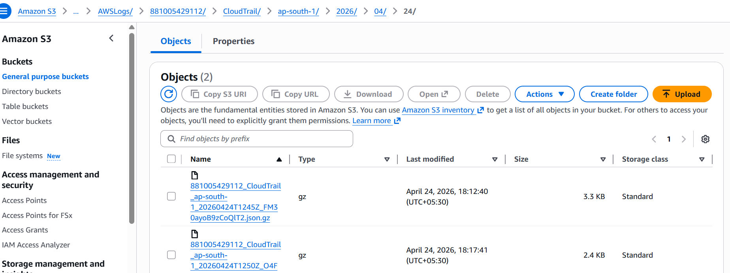
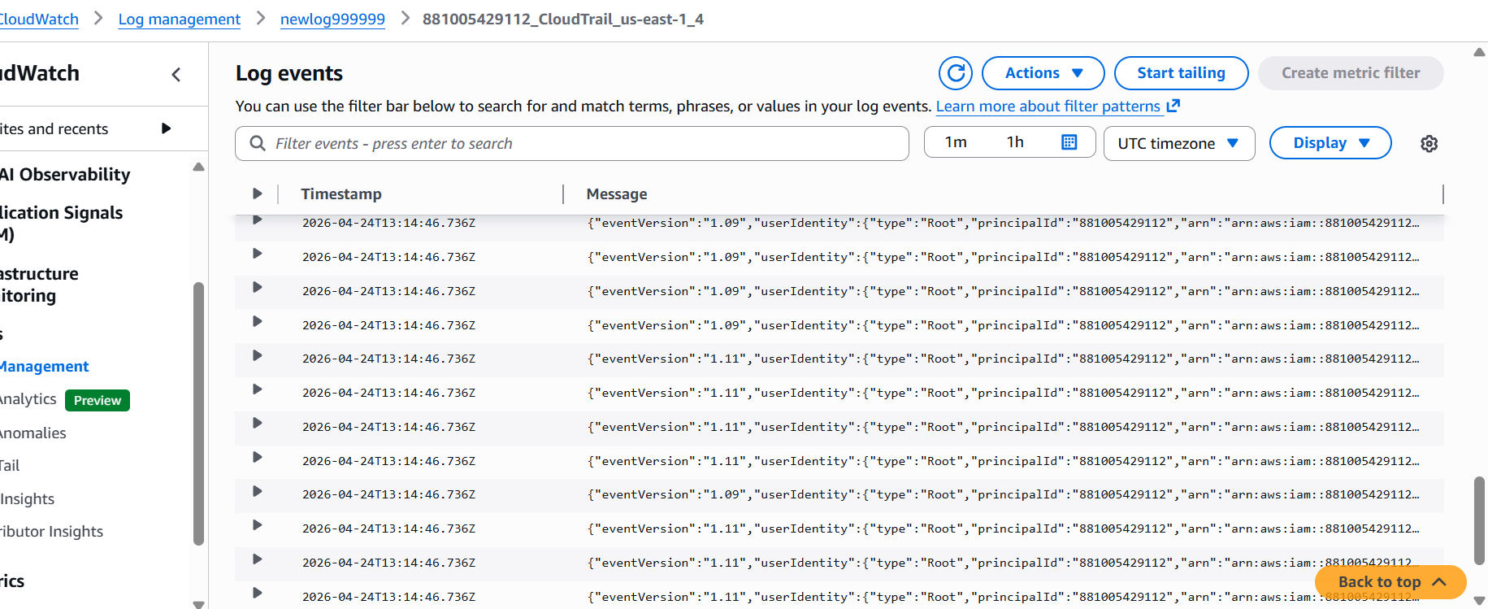

2.Enable SNS for CloudTrail to send alerts via email.
Created a SNS
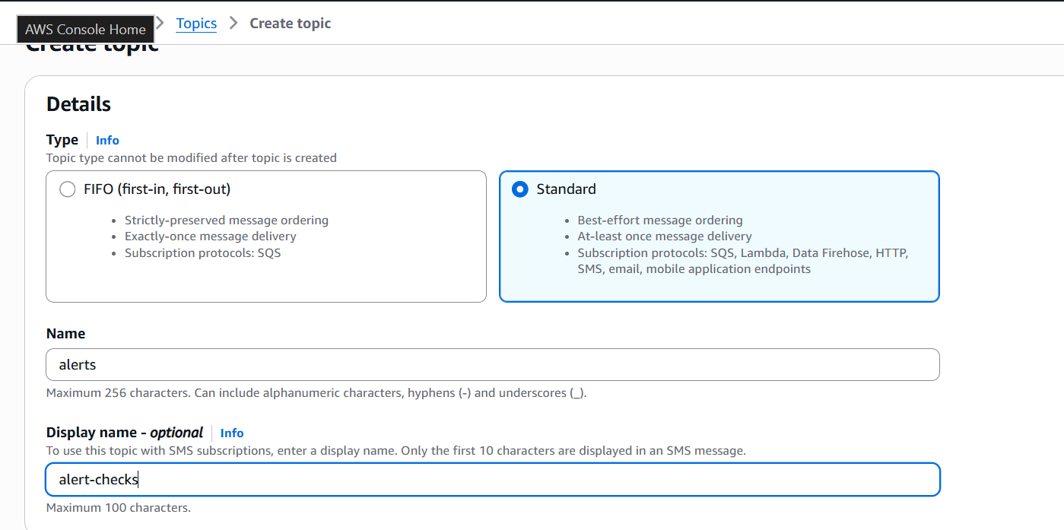
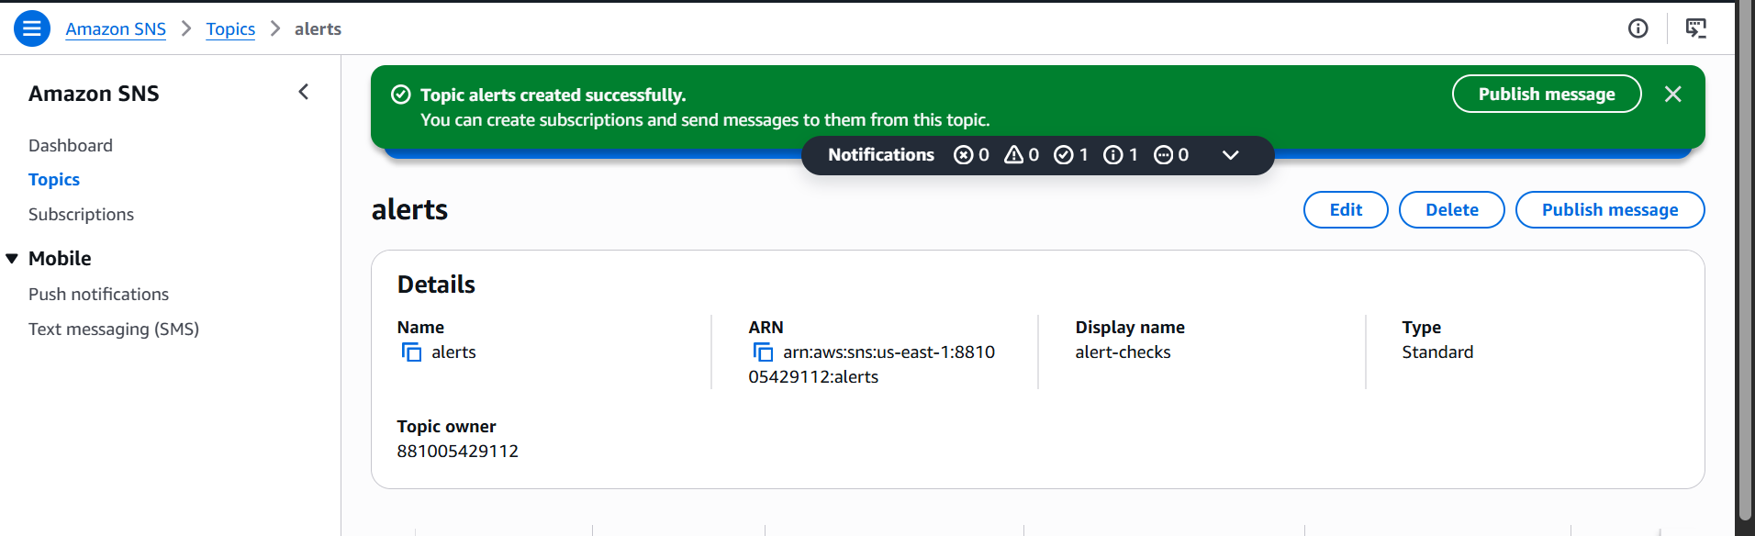
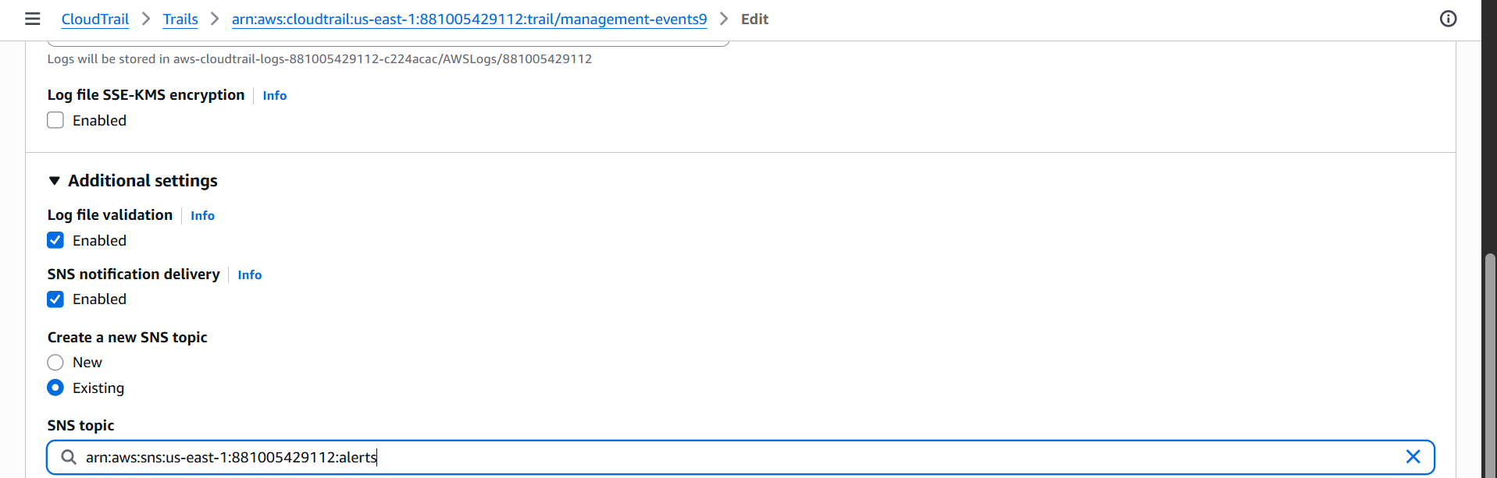
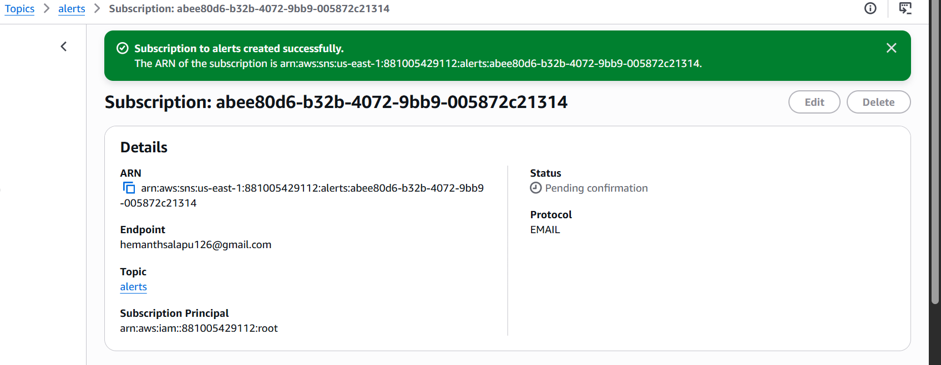
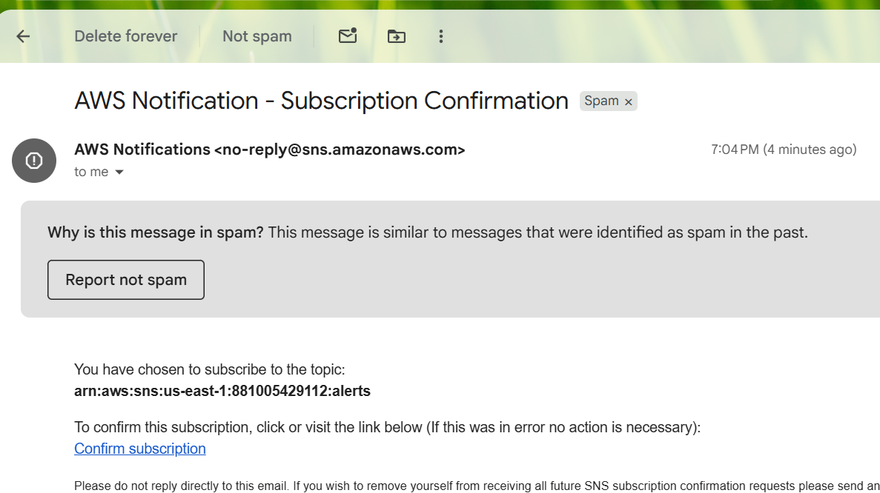
Successfully got the email conformation
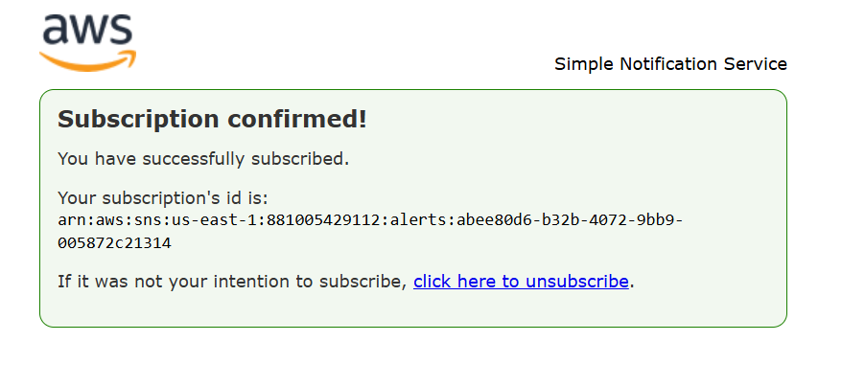
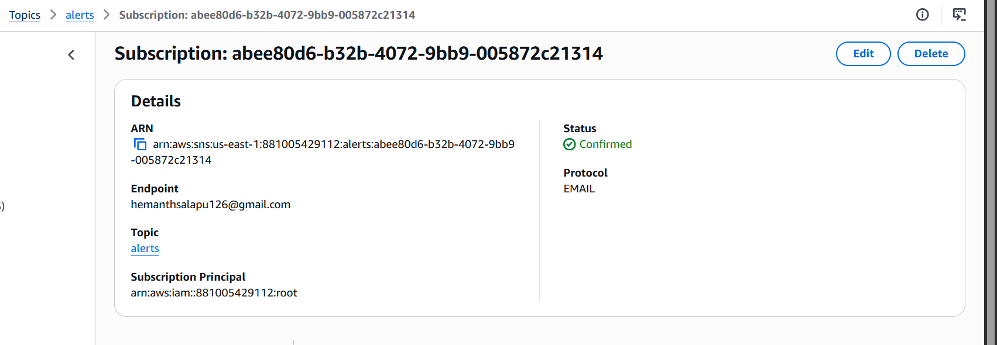
3.Configure CloudWatch monitoring and record the CPU utilization and other metrics of EC2.
Run any instance default
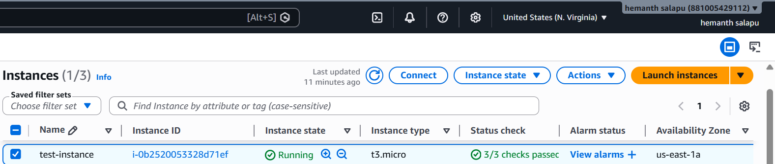
In that open Actions and enable the monitoring
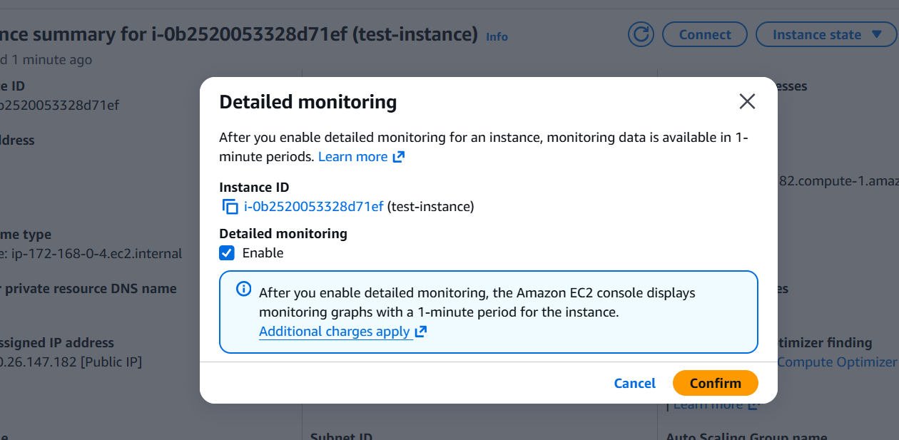

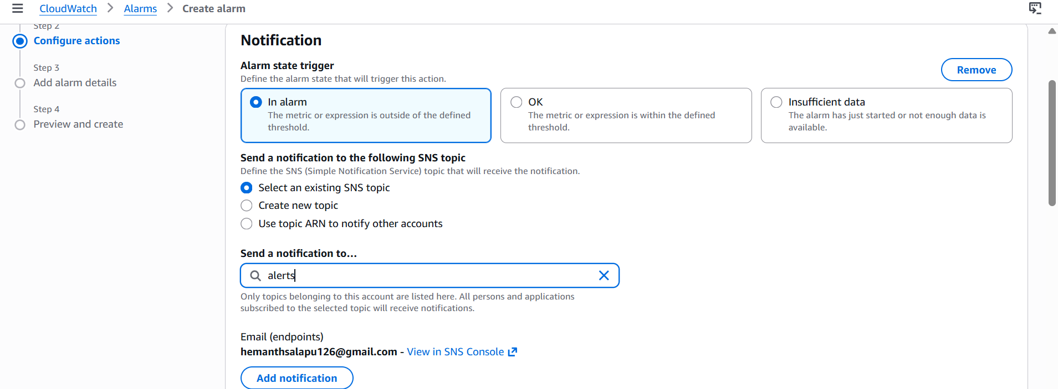
Change to 1 Minute for interval metrics
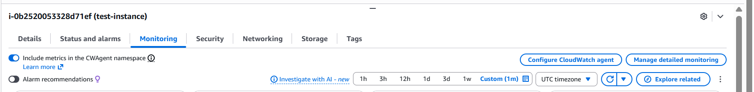

Before it was zero
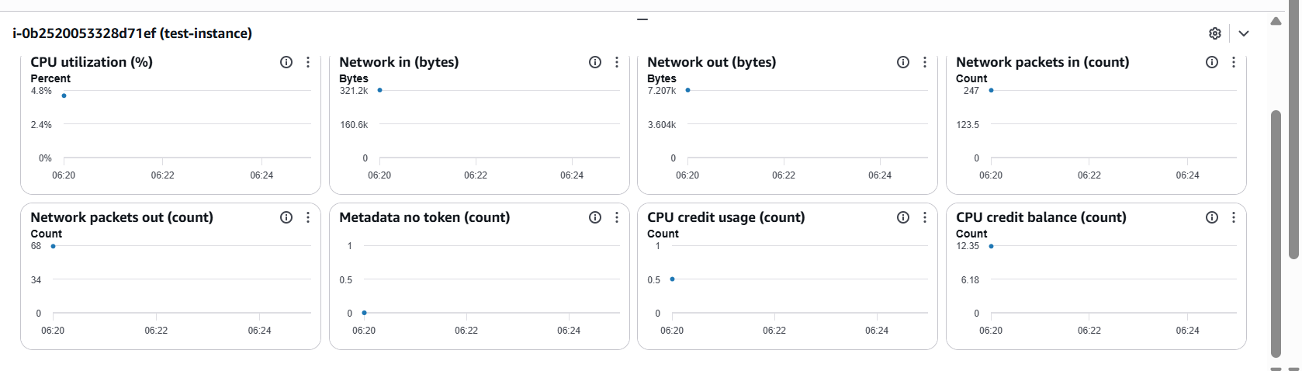
After Every 1 Minute the data is increasing Better accuracy for alarms
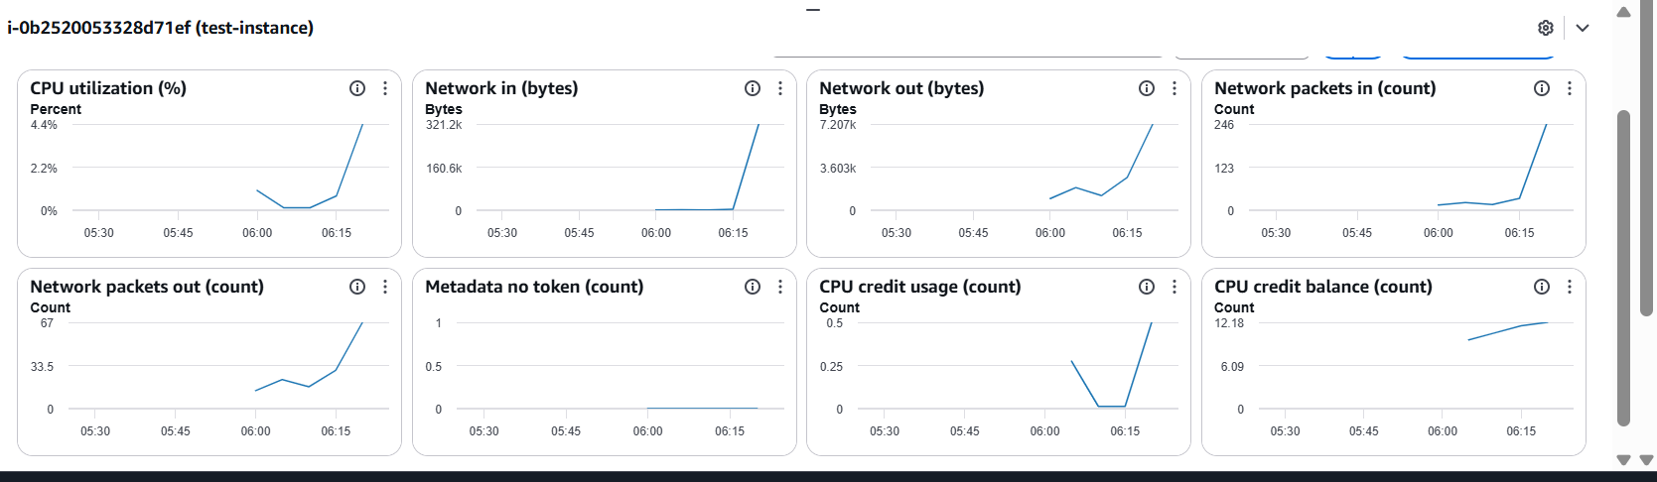
4. Create one alarm to send an alert to email if the CPU utilization is more than 70 percent.
RUN any Ec2 in AWS and Connect with pem in gitbash
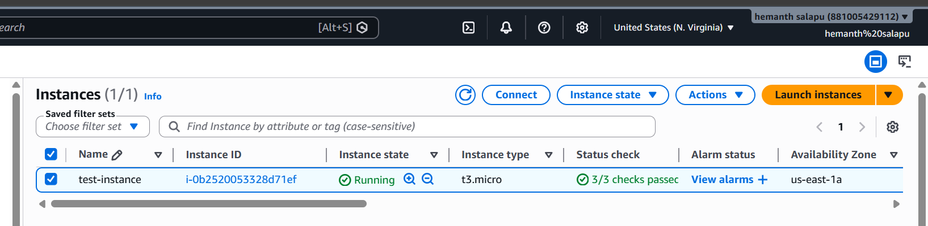
Create an alert message in alarm the and set more than 70 CPU utilization
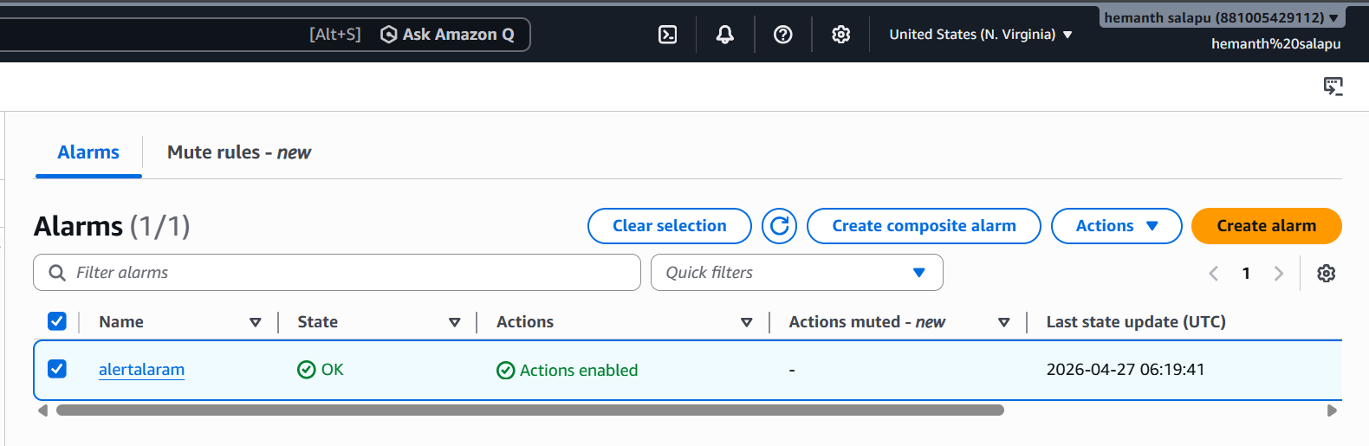

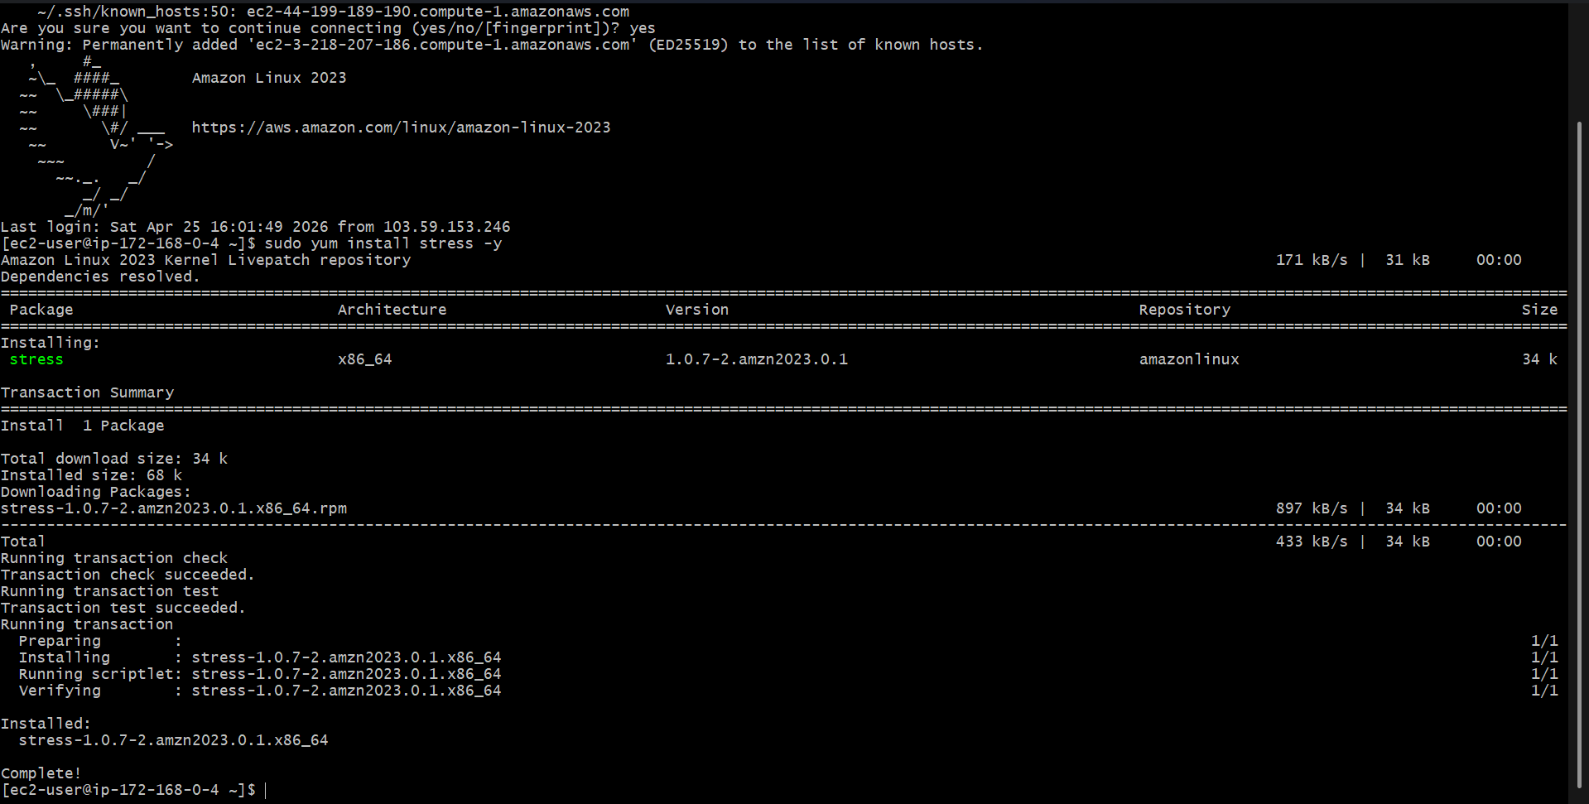
Run the EC2 and use the command for increase CPU Utilization
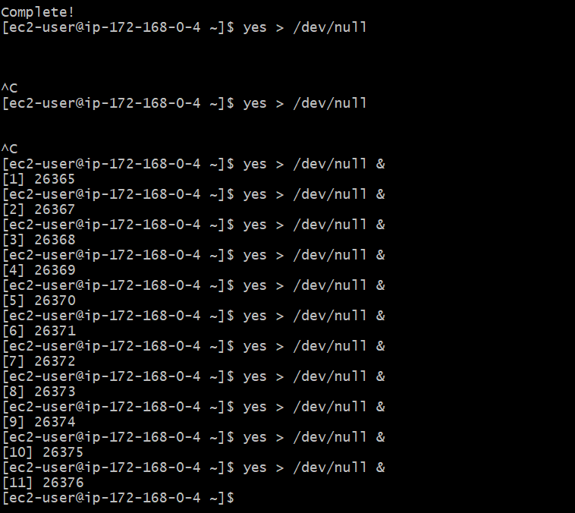

Once the CPU utilization increase to 100 kill the process
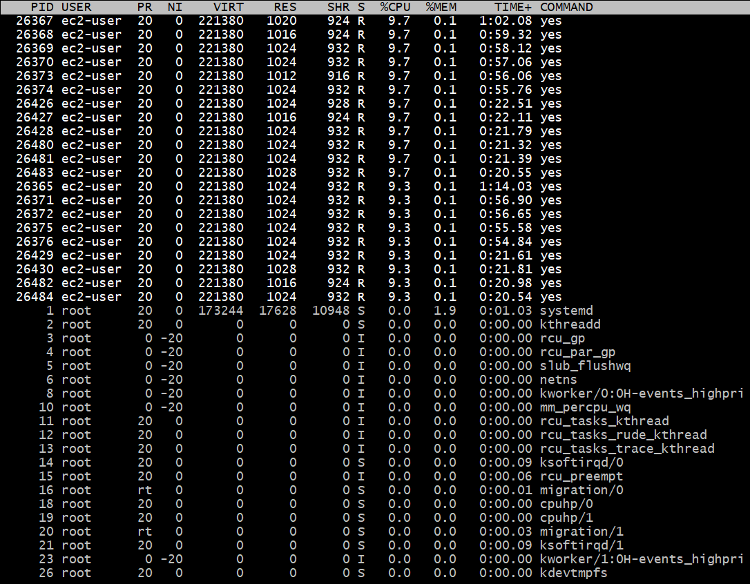

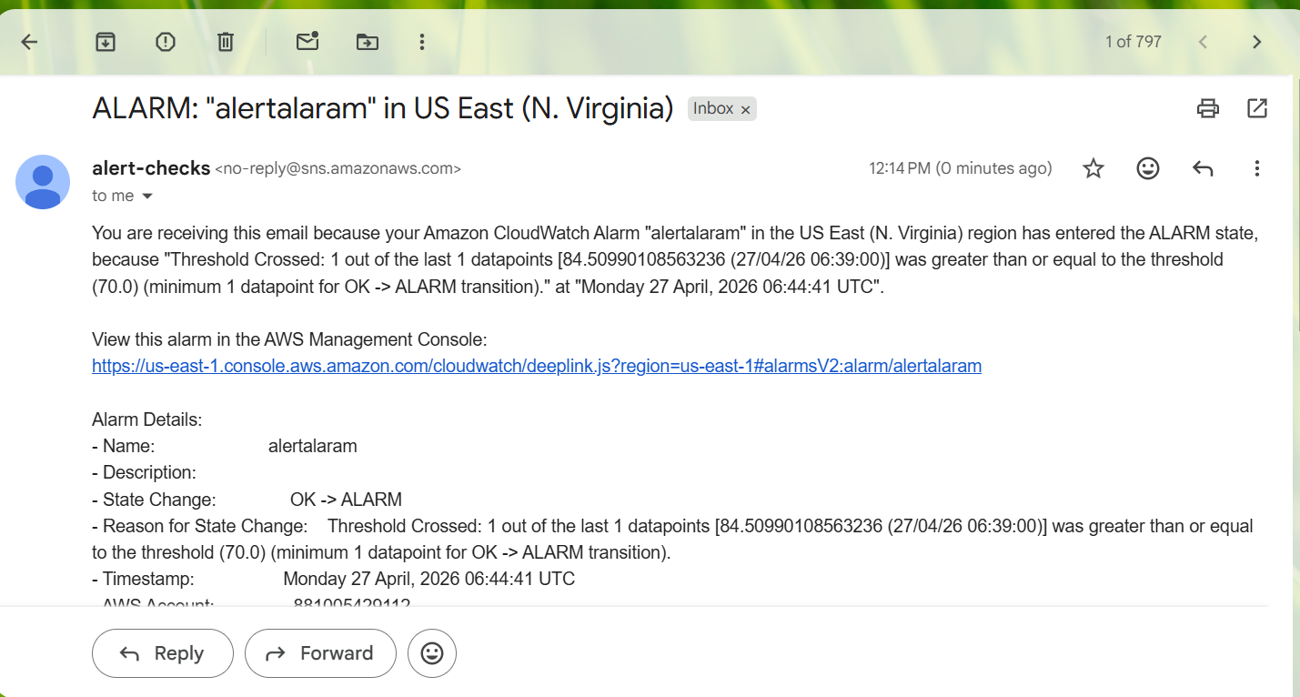
5. Create a Dashboard and monitor the Tomcat service whether it is running or not and send the alert.
New instance created and run
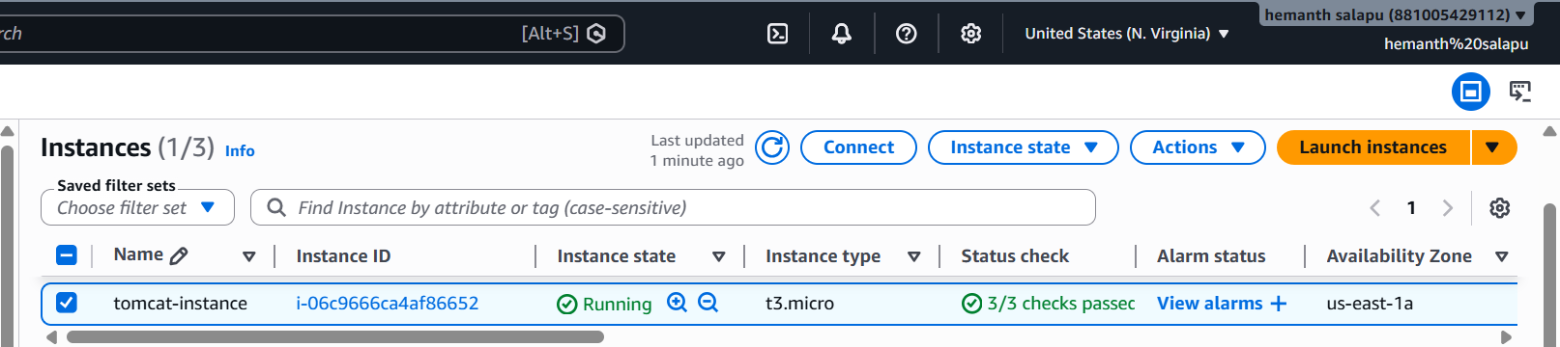
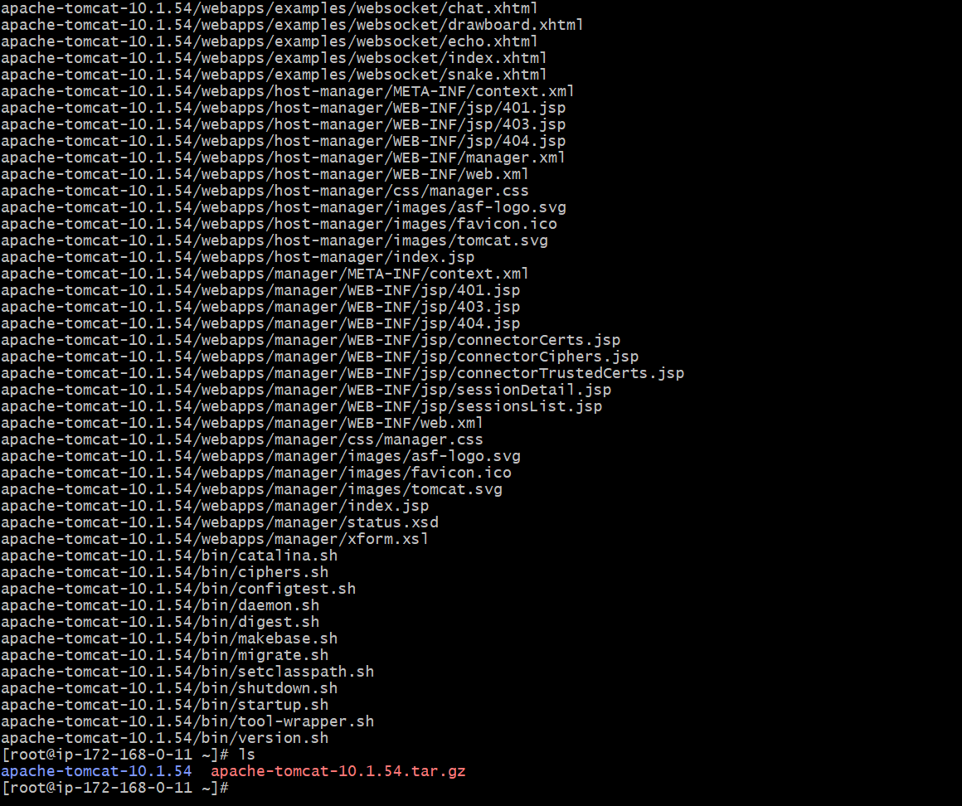
Installed tomcat Apache and Run it
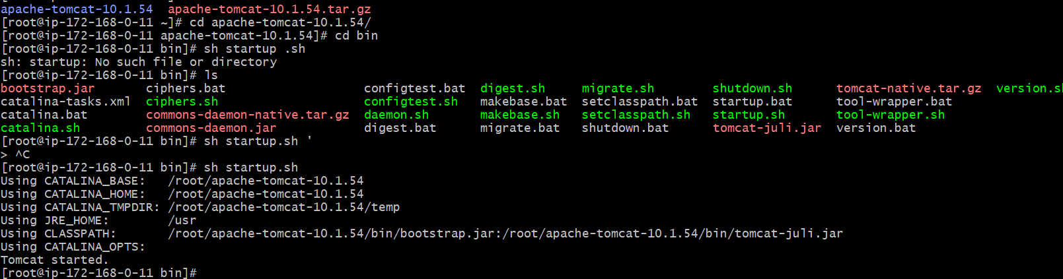
Now as I have created a custom script to get the tomcat service
Notification in Cloud watch and now I need to monitor that metric
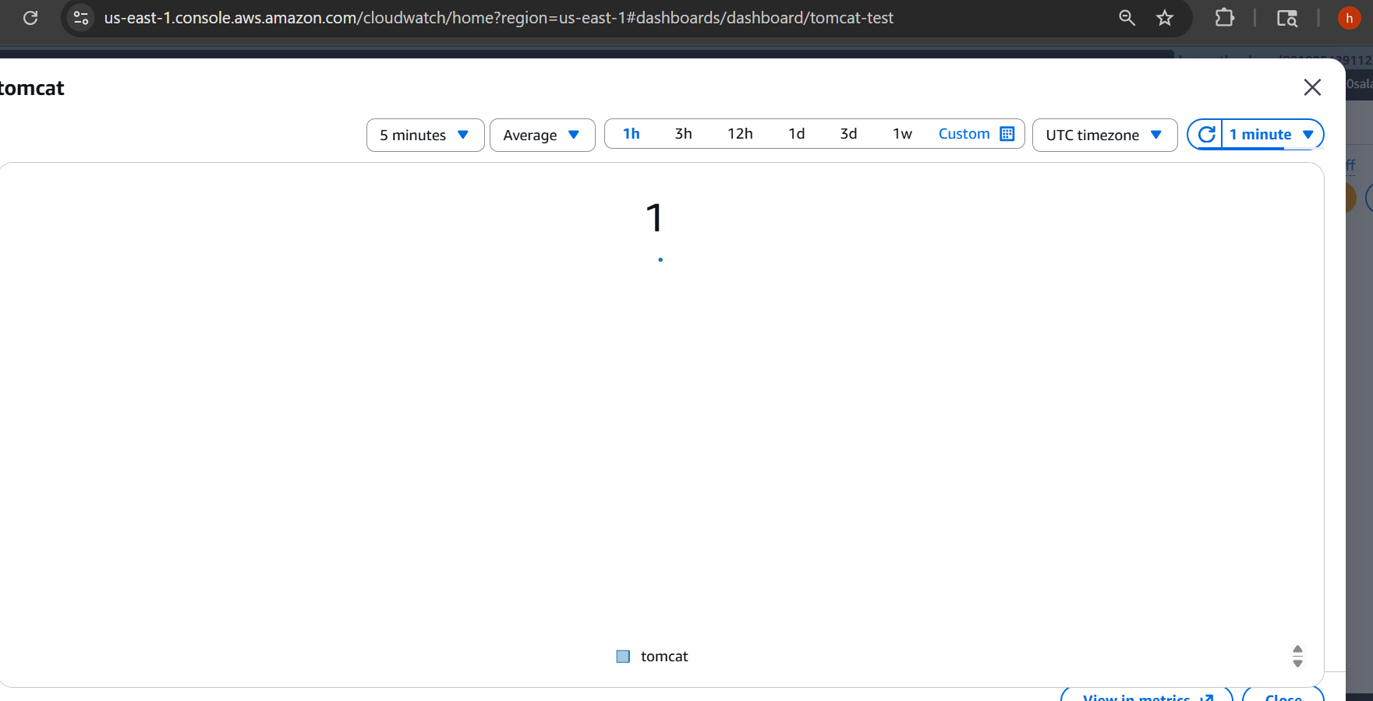

This is the script I have used to monitor cloud watch service
When it’s successfully running and open status
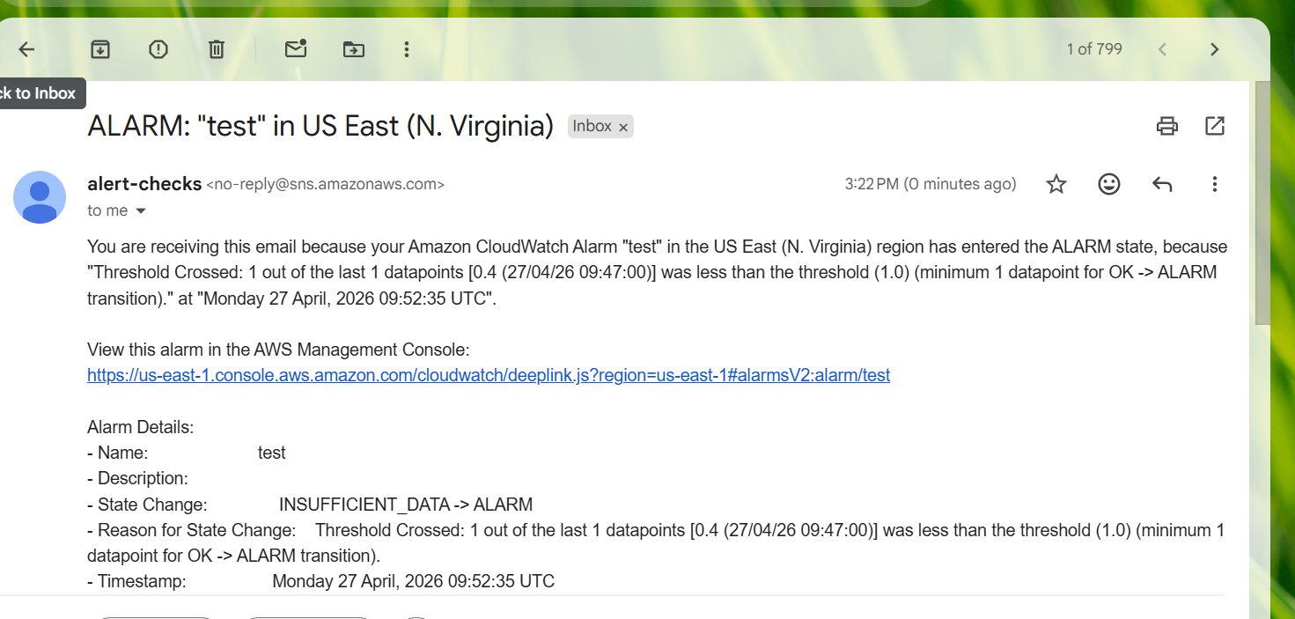
6.Create a Dashboard and monitor the Nginx service to send the alert if Nginx is not running.

install nginx and check the status In the server
Create script Like previous one and paste below
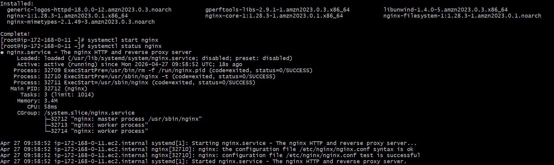
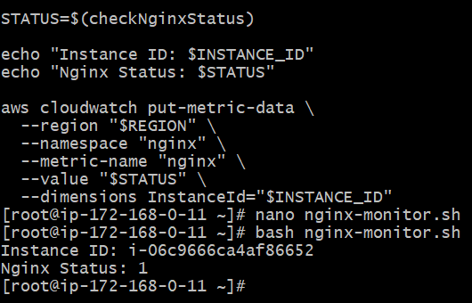
Created the New Dashboard
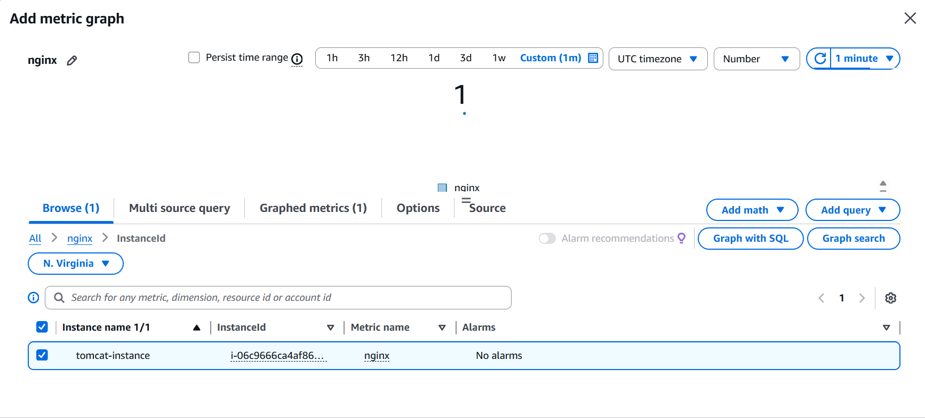
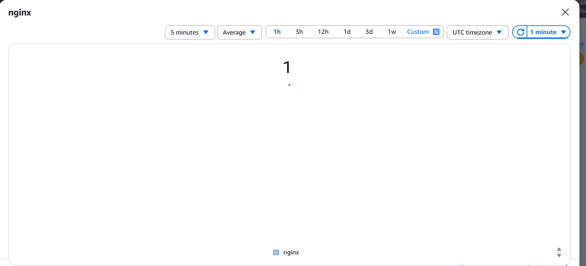
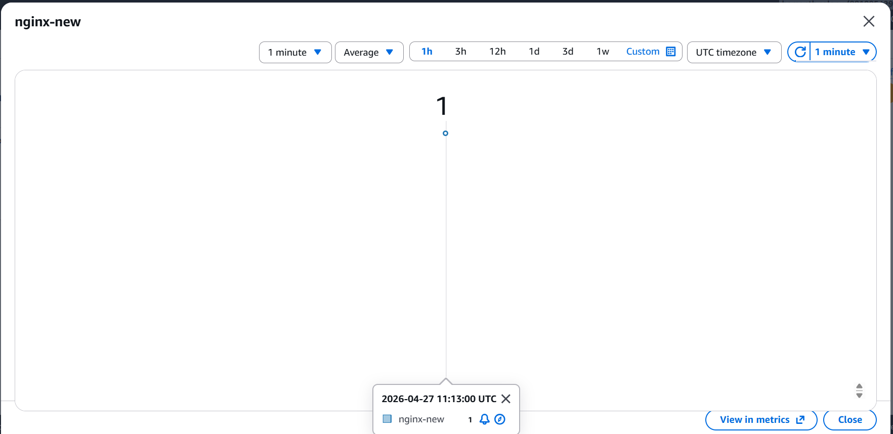
and I have created the alarm for that
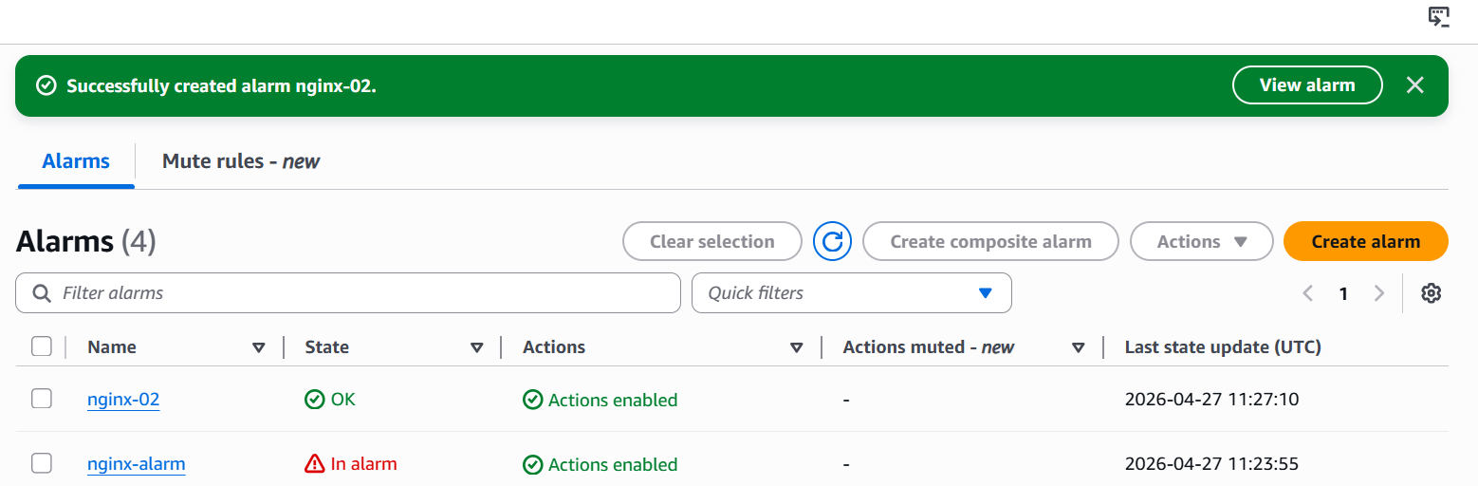
And I have received the mail also
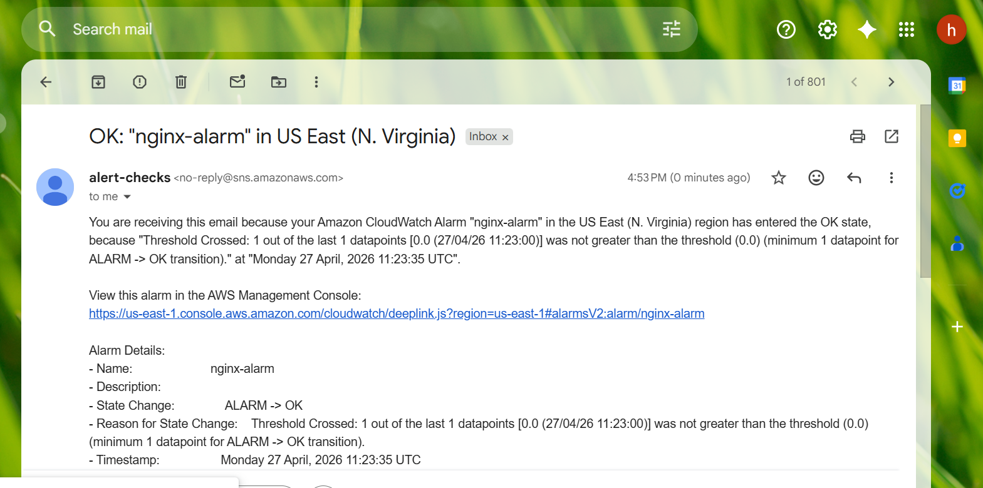
When I stopped I receive mail also

